Project Design Phase
Solution Architecture
Date | 07 September 2026
Team ID
Project Name | Automated Network Request Management in ServiceNow
Maximum Marks | 4 Marks

Solution Architecture:
The solution architecture defines how the ServiceNow components work together to automate network request submission, validation, approval, fulfillment, notification, and monitoring. The architecture bridges the business requirement for a simple and controlled network request process with the ServiceNow platform capabilities used to implement it.
- Provide a centralized Service Catalog and Service Portal entry point for network requests.
- Define the structure and behavior of the Network Request solution and its supporting ServiceNow components.
- Automate request processing, manager approval, fulfillment task creation, and request-state progression.
- Provide specifications for secure access, notifications, reporting, monitoring, testing, and deployment.

Architecture Components:
Component | Purpose
Service Portal | Provides the user-facing interface for submitting the Network Request catalog item.
Service Catalog – Network Request | Captures request type, access level, device, requester information, business justification, environment, priority, and request-specific details.
Requested Item (RITM) | ServiceNow creates the Requested Item record when the catalog request is submitted.
Flow Designer | Gets catalog variables, creates the Network Request record, requests manager approval, handles approval/rejection, and creates the fulfillment task.
Network Request table (u_network_request) | Stores the processed network request and its state, request details, priority, device, and other configured fields.
Approval | Manager approval determines whether the request proceeds to fulfillment or moves to Rejected.
Catalog Task / Network Team | Approved requests generate a fulfillment task assigned to the Network Team.
Notifications | Email notifications communicate important approval, rejection, and completion events.
Reports & Dashboard | Provides monitoring of requests by state, request type, priority, device, environment, open requests, pending approvals, and completed requests.
Roles & Groups | Network Requesters, Network Approvers, Network Team/fulfillers, and administrators provide controlled access to activities.

Example - Solution Architecture Diagram:
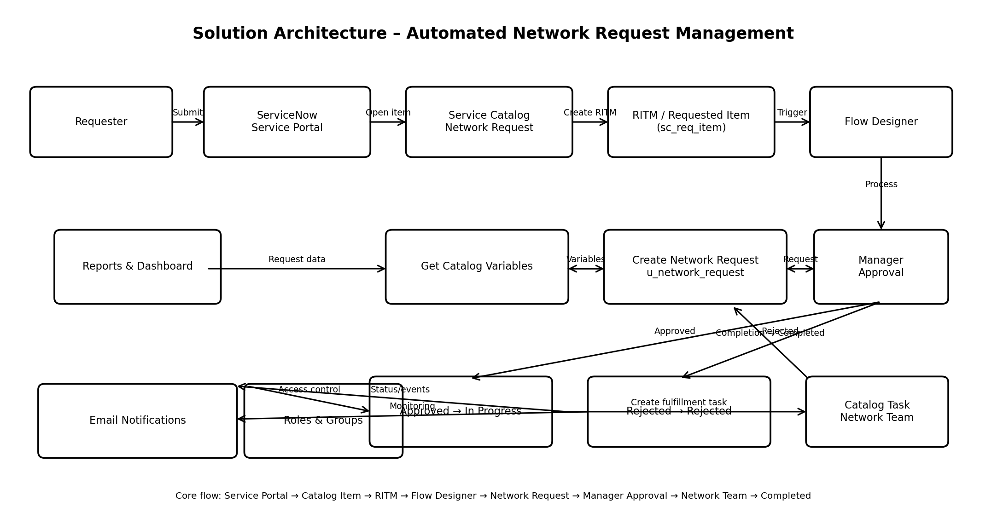
Figure 1: Architecture and data flow of the Automated Network Request Management solution

End-to-End Architecture Flow:
- The requester opens the ServiceNow Service Portal and selects the Network Request catalog item.
- The catalog form captures the required request information and uses dynamic fields and client-side validation where applicable.
- On submission, ServiceNow creates the Requested Item (RITM).
- The Service Catalog flow is triggered and retrieves the catalog variables.
- Flow Designer creates a Network Request record in u_network_request and stores the request information.
- The flow sends the request for manager approval.
- If approved, the request moves to In Progress and a Catalog Task is created for the Network Team.
- The Network Team performs the fulfillment work and completes the task; the request then moves to Completed.
- If rejected, the request moves to Rejected.
- Notifications, reports, and the dashboard provide visibility into important request events and operational status.

